DCAPXOwners Guide

DCAPXOwners members should be the IT team, not AOs.

You must be a member of the DCAPXOwners group to perform the following operations.

# How to add a new OTA user

Click Program Contacts in left menu.

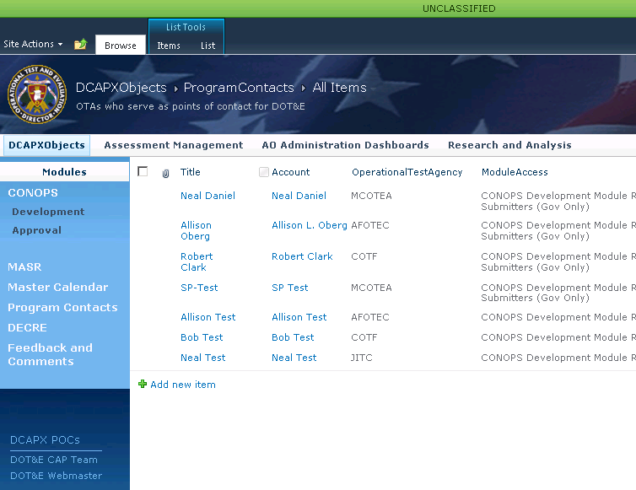

Click Add new item.

Enter information into the form. 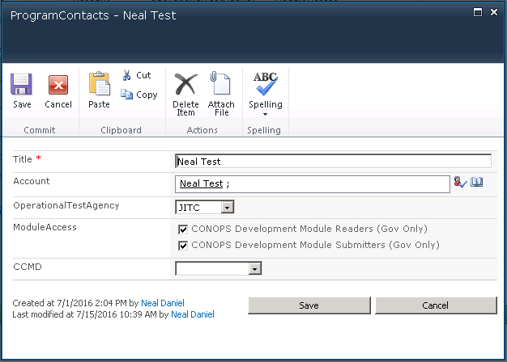

Check Permissions to verify user has been added to correct groups.

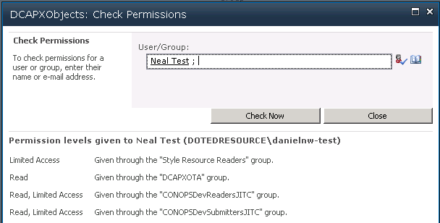

Add or remove the user from any groups on the /_layouts/user.aspx page if this method fails. (Repeated updates to the user’s information in the Program Contacts list may result in the user not being removed from a group.)

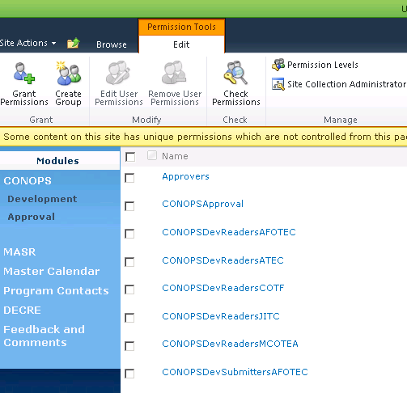

By the way, if an OTA clicks on the Program Contacts link to manage their associates, the following form appears…

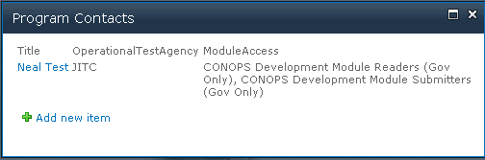

# How to add a new site collection admin

Assuming you are a site collection administrator, click Site collection administrators from the Site Settings page on /sites/site collection name.

Add the user in the form.

Be sure to also add the user to the DCAPXOwners group.

# How to activate features on the web app root and /sites/DCAPX

Reactive features if you suspect an object is missing.

Be sure to Deactivate DCAPXSolution Feature 3, then 2, then 1.

Then Activate DCAPXSolution Feature 1, then 2, then 3.

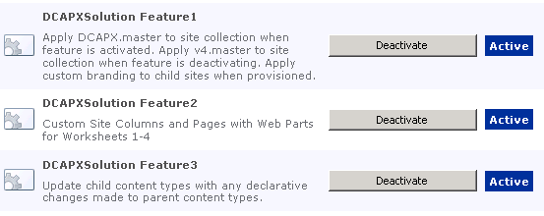

# How to hide navigation elements

DCAPXOwners see navigation elements not available to AOs or OTAs for Assessment Management, Research and Analysis, MASR, DECRE.

If Audience Targeting is not set go to the Site Settings, Navigation Settings page.

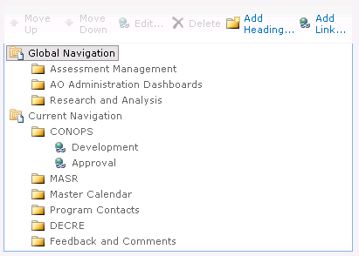

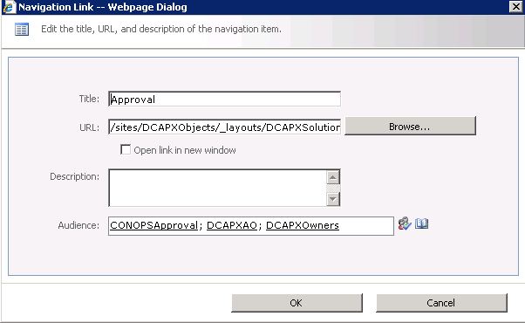

OTAs should not see the link to the CONOPS Approval page (although if they did go there the page would display an error message).

Target groups should look like this….

Assessment Management (DCAPXOwners)

AO Administration Dashboards (CONOPSApproval; DCAPXAO; DCAPXOwners)

Research and Analysis (DCAPXOwners)

Approval (CONOPSApproval; DCAPXAO; DCAPXOwners)

MASR (DCAPXOwners)

Master Calendar (DCAPXOwners)

DECRE (DCAPXOwners)